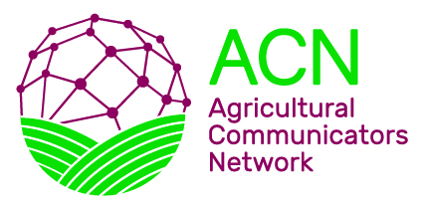 | 2023 Scholarship Reference Form

Name of Applicant:

The above-named student has applied for an Agricultural Communicators Network (ACN) scholarship. Although funded by ACN and its Professional Improvement Foundation (PIF), this award is open to any undergraduate Agricultural Communicators of Tomorrow (ACT) member who is currently enrolled at a university or college, regardless of the specific communications career path. It is based on the following criteria: ACT involvement and leadership activities, academic achievements, career-related experiences, and reference recommendations.

Please give your opinion, in confidence, of the applicant’s character, experience and potential as they relate to the applicant’s qualifications for this scholarship. Any other comments you may be able to offer regarding the applicant’s suitability for this award will be appreciated.

Please seal your reference letter and this completed form in a business envelope and sign across the flap. The student should submit this envelope at the same time he/she mails the completed application form. Or you may email this completed form and your reference letter to cllgirgis@gmail.com with the subject “ACN scholarship letter for ‘name of student.’”

You and the student must send all materials no later than end of day APRIL 3, 2023.

Thank you for your support and efforts to benefit the National ACT and tomorrow’s agricultural communicators.

Please type or print:

Name:
Last First

Title:

Organization/Company:

Address:
Street City State/Province Zip Code

Telephone Number: ( )

Email address:

