2023 Scholarship Application Form
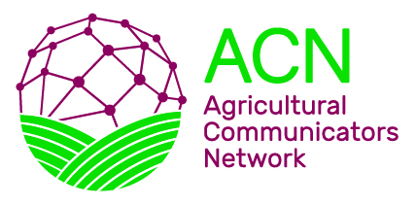

Please type or print.
Name (First, Last): _____________________________________________________
Current Address: _____________________________________________________
Permanent Address: _____________________________________________________
Phone: _____________________________________________________
Email address: ______________________________________________
University/College: ______________________________________________
Major Course of Study: _____________________________________________________
Academic Classification (undergraduates only, please): _______________________________
Date of Anticipated Graduation: ______________________________________________
Please include the following with your application form:
- Cover letter. In this letter, include why you are pursuing a career in agriculture and how this scholarship will help you achieve that goal.
- Resume. The information below should be included.
  - ACT involvement, leadership activities, and other campus organizational involvement. List and/or describe ACT activities in which you have participated. Please be specific regarding offices held, committee participation, and other major responsibilities.
  - Academic achievements. List any academic achievements, awards, honors or scholarships.
  - Internships and career-related experiences.
- References. Give the Agricultural Communicators Network reference form to no more than two individuals who can serve as professional and/or character references. Only one reference can be affiliated with your university. Please do not use ACT advisers as a reference.

All materials, including reference letters, must be postmarked on or before MONDAY, APRIL 3, 2023.

Email or mail applications and reference letters to:

Courtney Girgis
Rooted Communications
7701 S Triple X Road
Choctaw, OK 73020
cllgirgis@gmail.com

